Chapter 1, Problem 1.

How many coulombs are represented by these amounts of electrons:
(a) 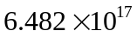 (b) 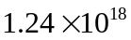
(c) 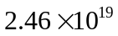 (d) 